1.Introduction to Programming & C

Write a C program to print "Hello, World!" on the screen.

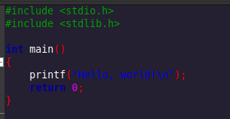
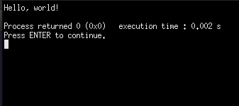

Write a program to display your name, age, and university using printf.

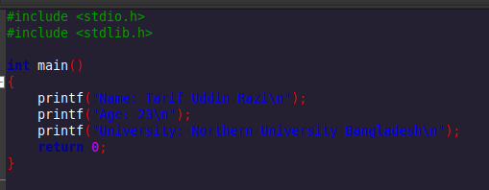
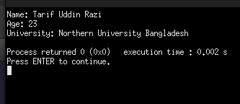

Create a program that prints the sum of two numbers entered by the user.

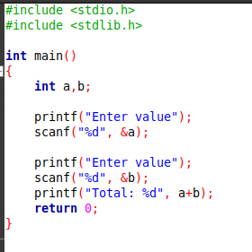

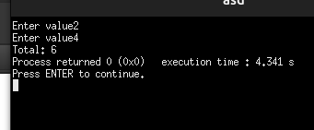

Write a C program to swap two numbers using a temporary variable.

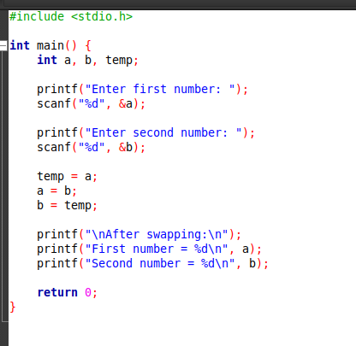

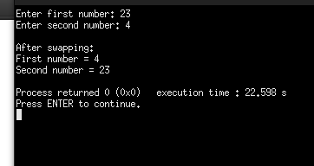

Write a program to calculate the area of a rectangle.

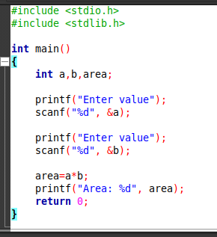

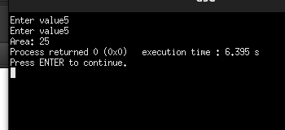

Write a program to convert temperature from Celsius to Fahrenheit.
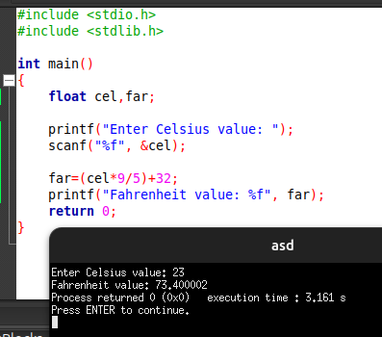

Write a program to display the ASCII value of a character entered by the user.
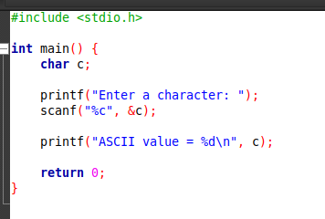

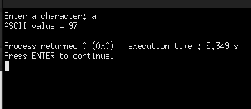

Write a program to take user input for two integers and display their product.

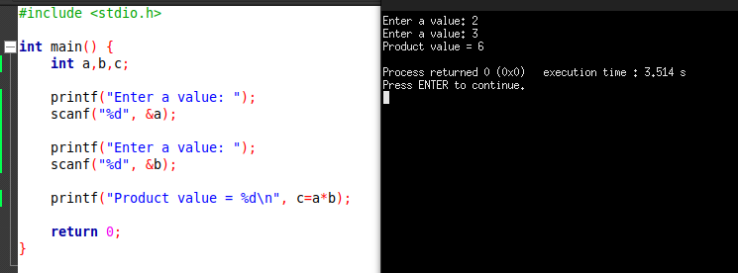

Create a simple calculator that performs addition, subtraction, multiplication, and division.

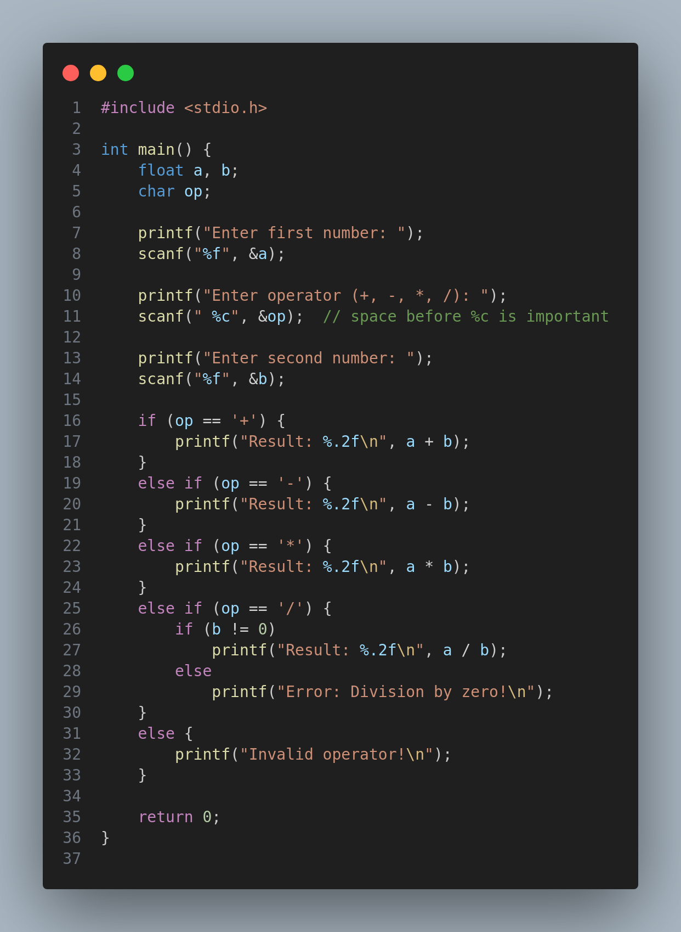

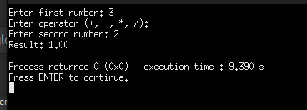

Write a C program to find the square and cube of a given number.
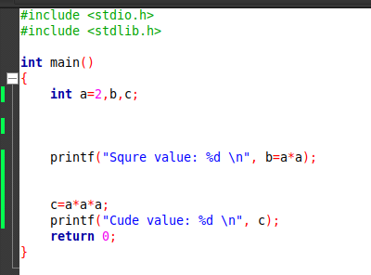

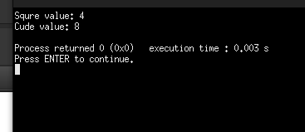

2. Basic Syntax & Data Types

Write a program to declare and initialize variables of different data types and print their values.
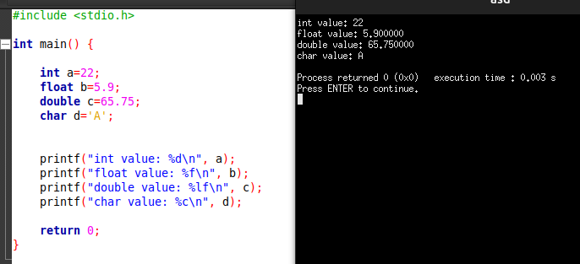

Write a program to take two integer inputs and perform all arithmetic operations on them.

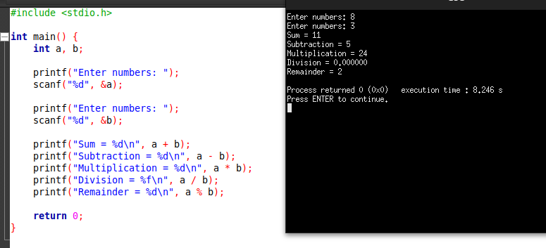

Create a program that checks whether a given number is even or odd.
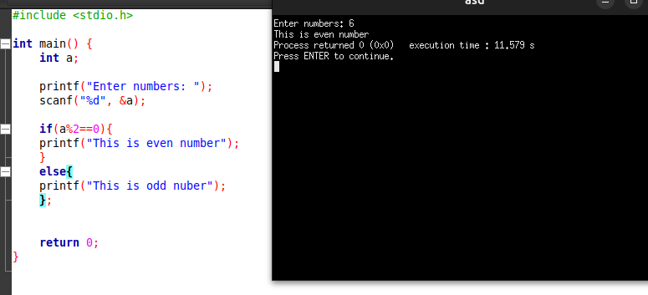

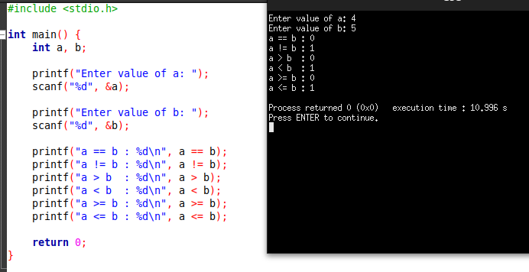
Write a program to demonstrate the use of relational operators.

Write a program to compute the area and circumference of a circle using float data type.
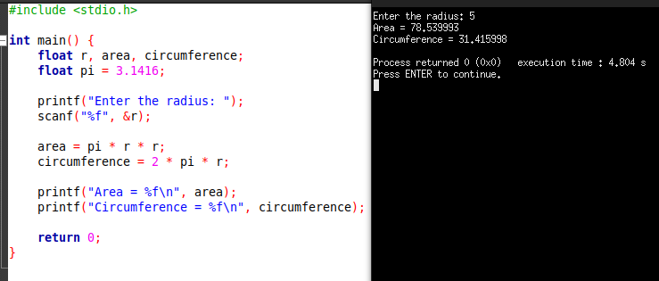

Write a program that takes a character as input and prints its ASCII value.
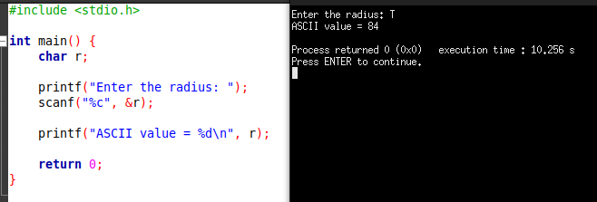

Write a program to take an integer input and display its binary equivalent.
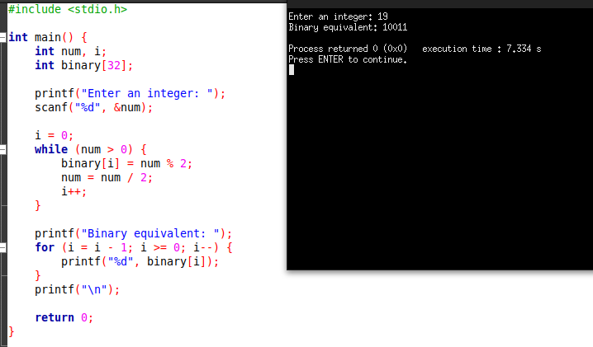

Create a program that calculates the power of a number without using the pow() function.
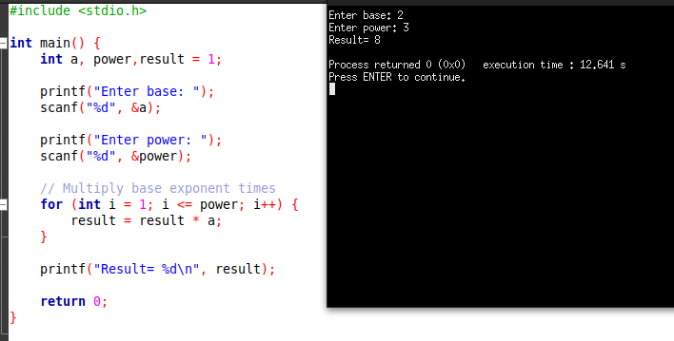
Write a program that performs bitwise AND, OR, and XOR operations on two numbers.
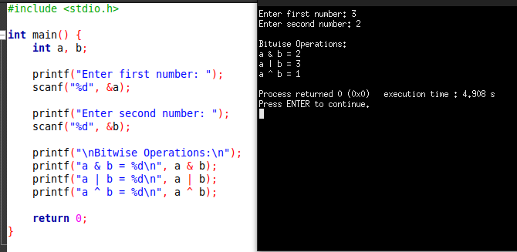

Write a program to demonstrate the use of the modulus operator.
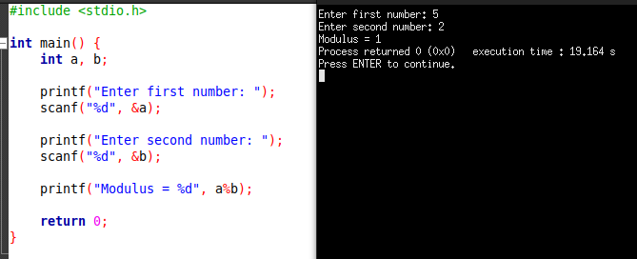

2. Input and Output

Write a program to take an integer as input and print it.
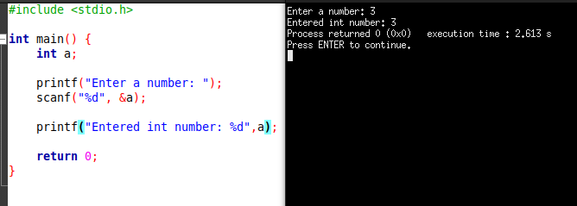

Write a program to take a floating-point number as input and display it with two decimal places.

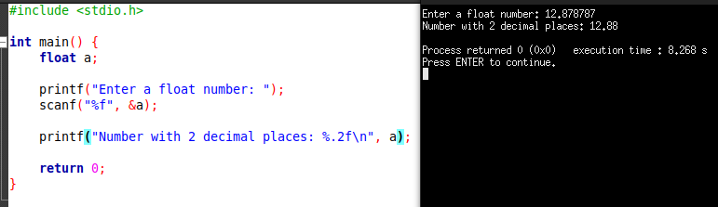

Create a program that takes two integer inputs and prints their sum.

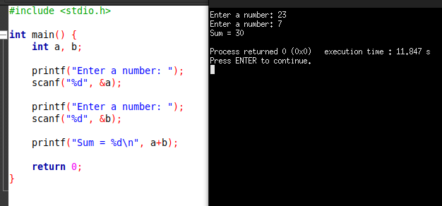

Write a program that reads a character and prints it along with its ASCII value.

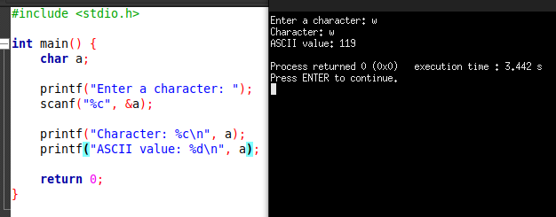

Write a program to take a sentence as input and display it using puts().
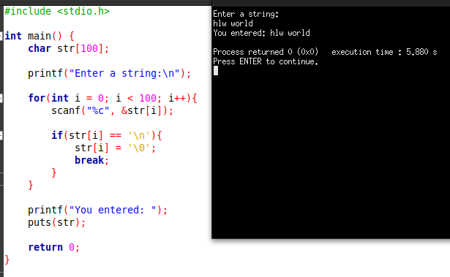

Write a program to display a number in scientific notation using printf.
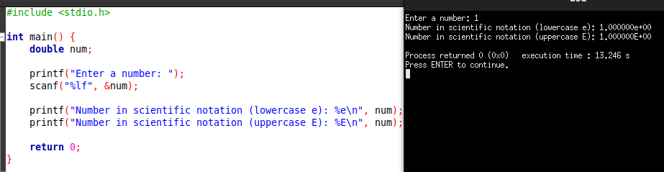

Create a program that formats the output using setw(), setprecision(), and fixed. (Used C here)
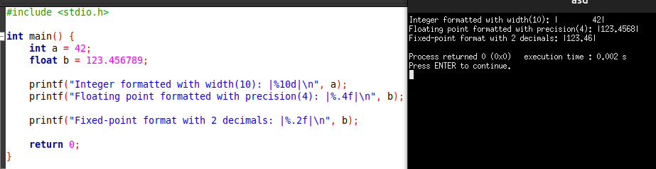

Write a program that takes user input and displays it in reverse order.

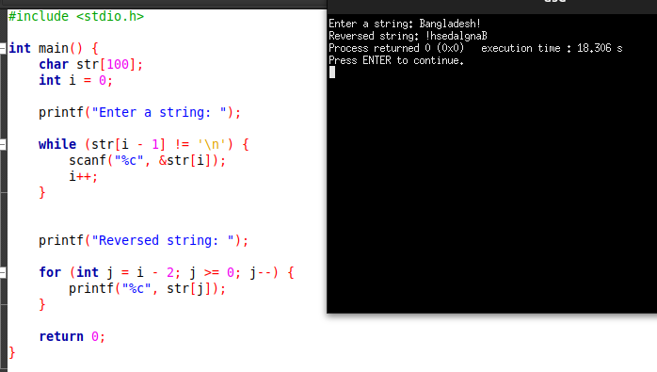

Write a program to read two space-separated integers in a single input statement and print them.
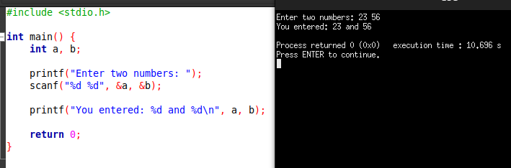

Write a program that takes three inputs and displays them in different data types.
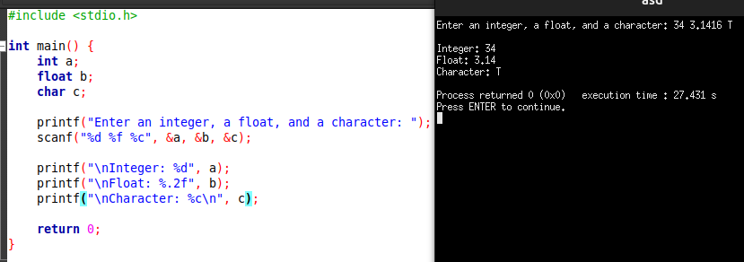

4. Control Flow Statements

Write a program to check if a number is positive, negative, or zero.
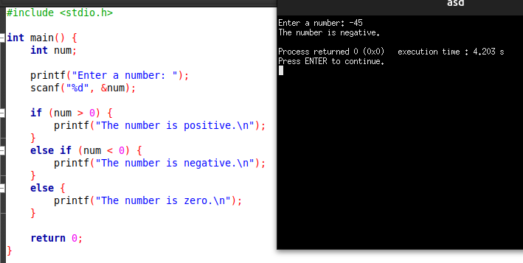
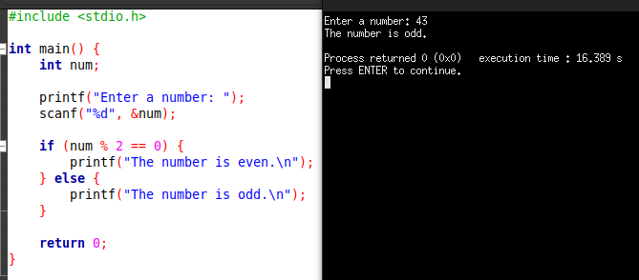
Write a program that checks if a number is even or odd using the if-else statement.
Create a program that finds the maximum of three numbers using if-else.
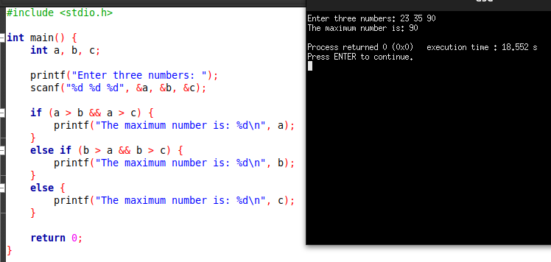
Write a program to check if a given year is a leap year.
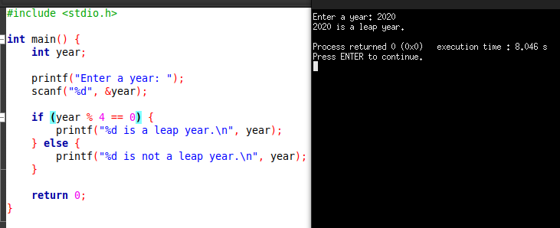
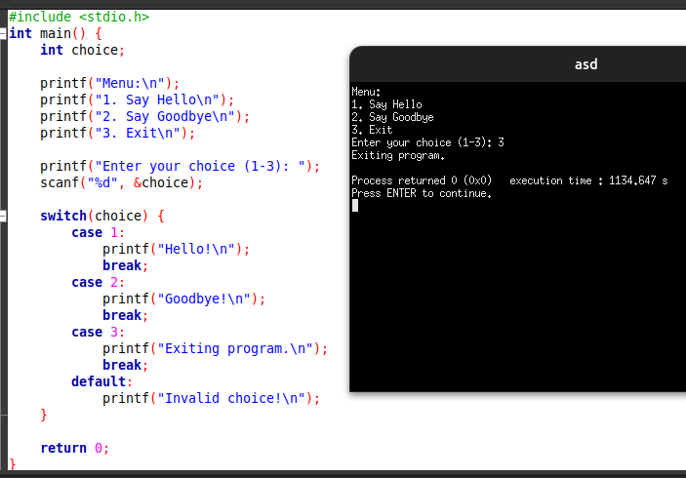
Create a program to display a menu and take user input using a switch statement.

Write a program to check if a character is a vowel or consonant using switch.
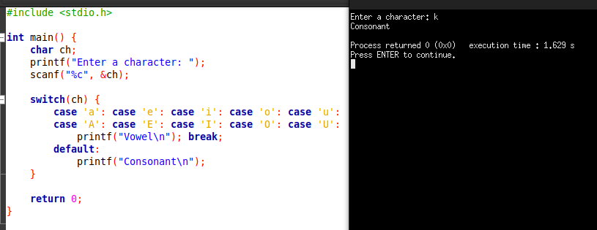
Write a program that prints all even numbers from 1 to 100 using a for loop.
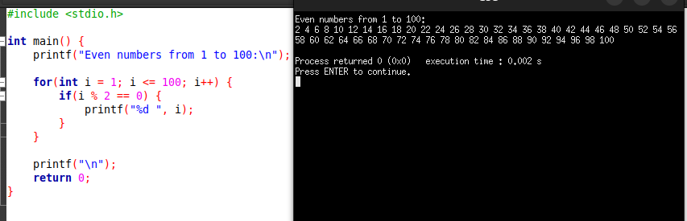

Write a program to print the sum of all numbers from 1 to N using a while loop.
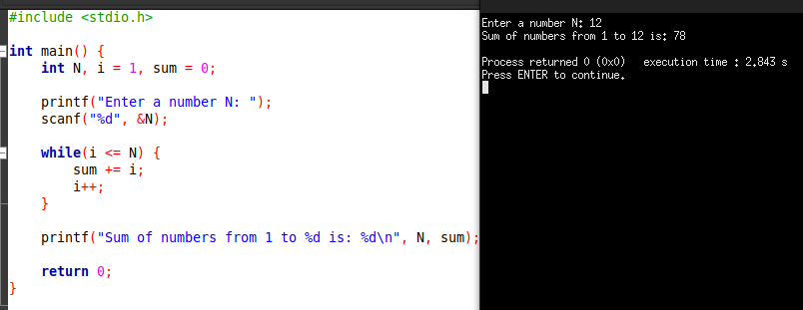

Create a program that generates the Fibonacci series up to N terms using a do-while loop.
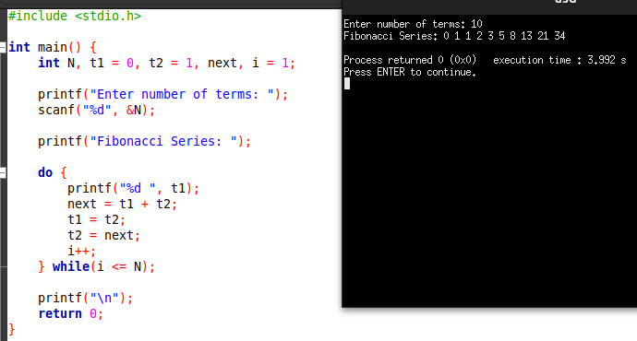
Write a program to check if a number is prime.
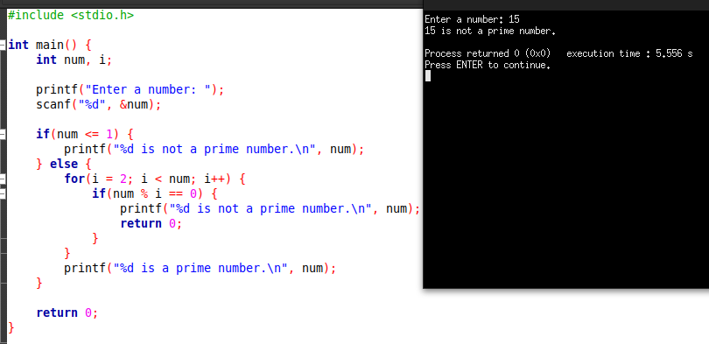
5. Functions

Write a function to return the sum of two numbers.
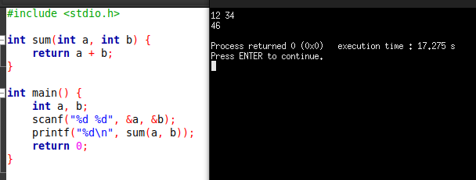

Write a function to find the factorial of a number.
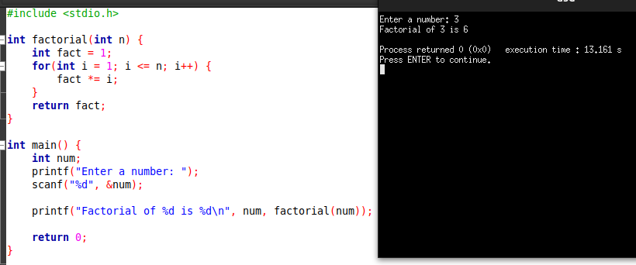
Create a function to swap two numbers using call by reference.
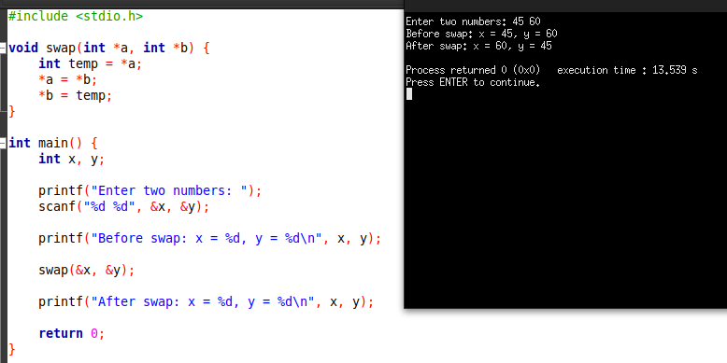

Write a function to check if a number is prime.

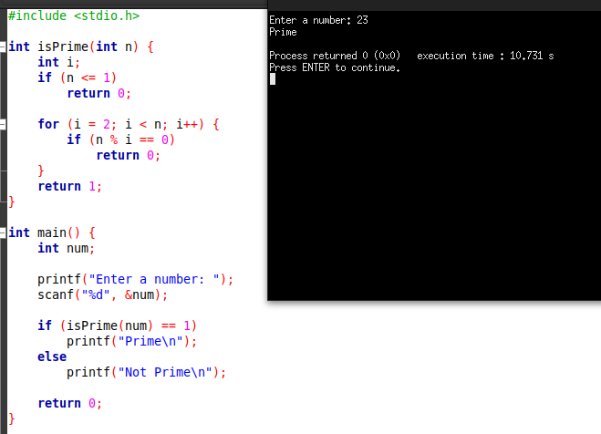

Write a recursive function to calculate the Fibonacci series.
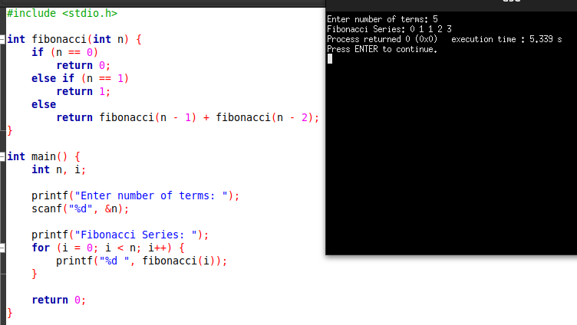

Write a function to calculate the greatest common divisor (GCD) of two numbers.
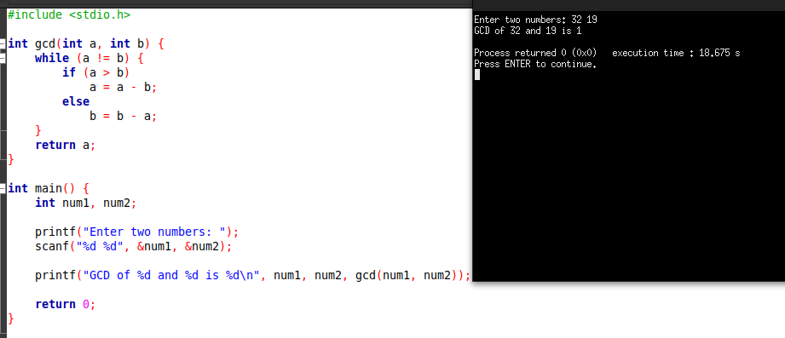

Write a function to convert Celsius to Fahrenheit.
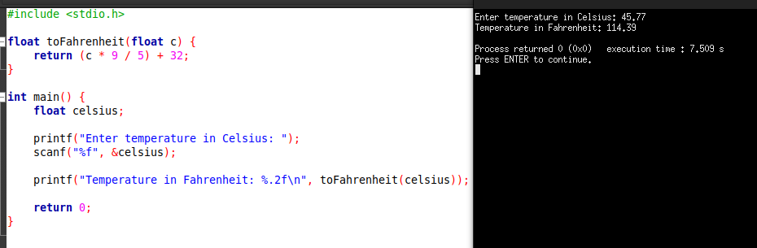
Create a function to check whether a string is a palindrome.
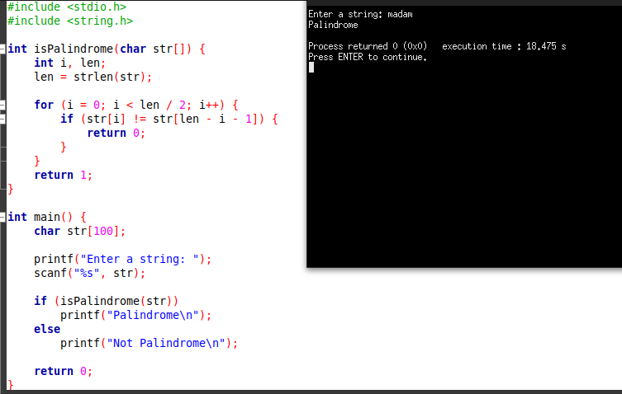

Write a function to return the maximum element in an array.
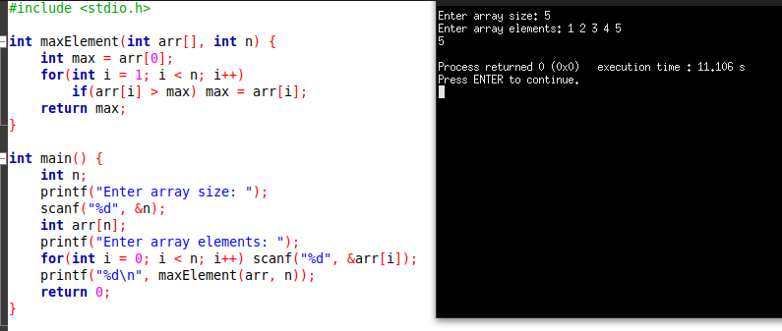

Write a function to calculate the power of a number.
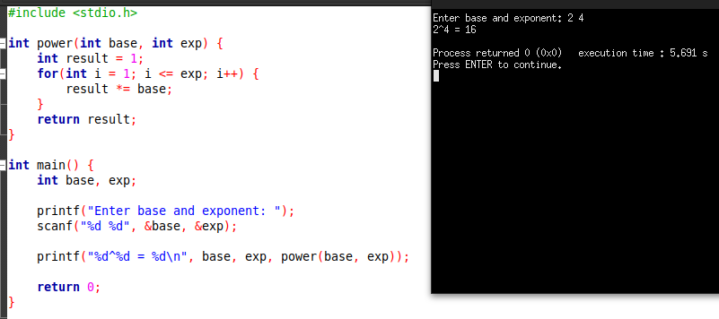

6. Arrays and Strings

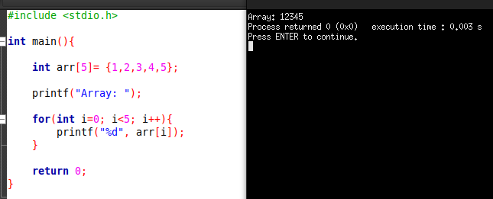
Write a program to take an array of 5 integers and print them.

Write a program to find the maximum and minimum element in an array.
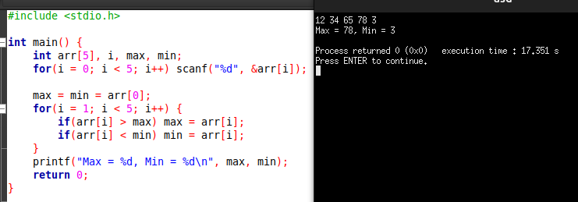

Write a program to reverse an array.
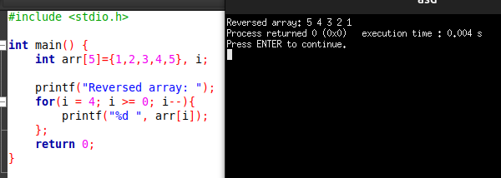

Create a program that finds the sum of all elements in an array.
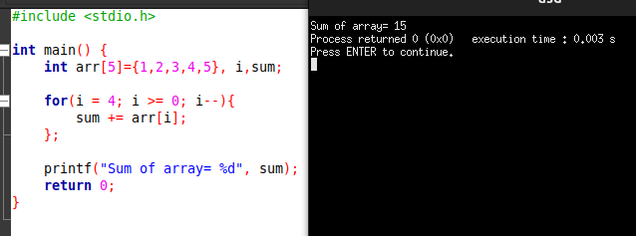

Write a program to perform matrix addition.
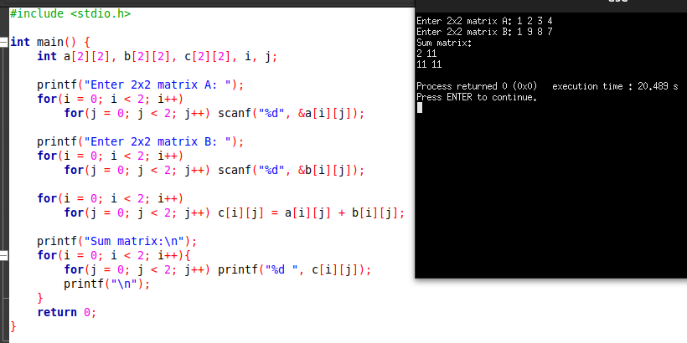
Write a program to search for an element in an array.
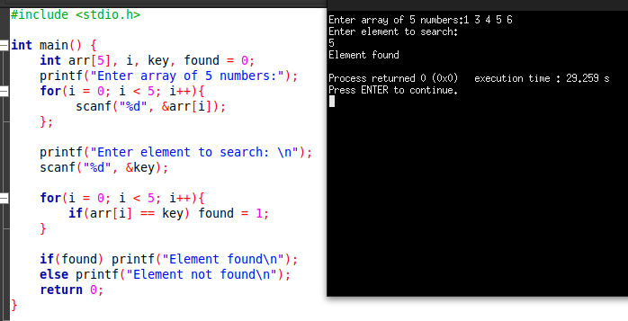
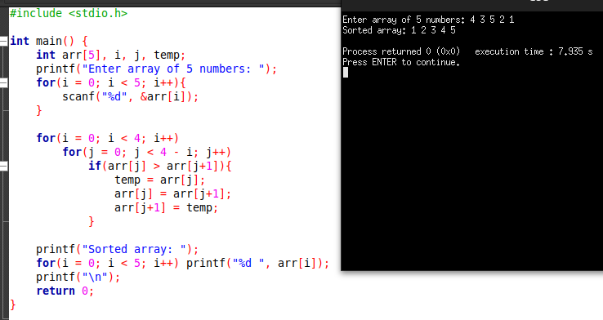
Write a program to sort an array using bubble sort.

Create a program that counts the number of vowels in a string.
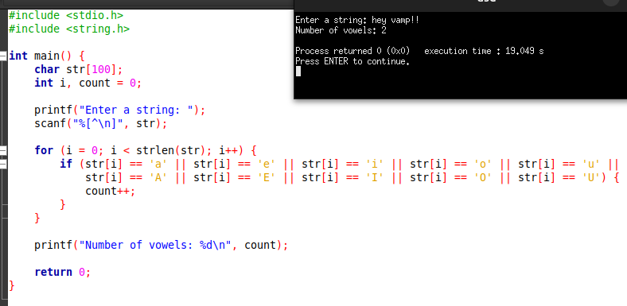
Write a program to concatenate two strings.
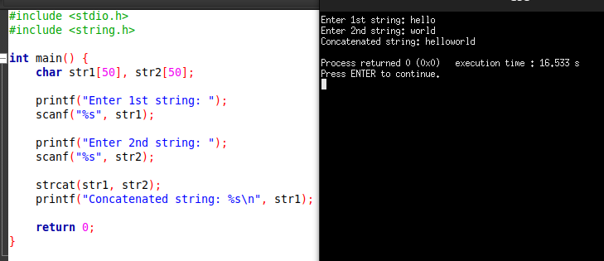
Write a program to check if a string is a palindrome.
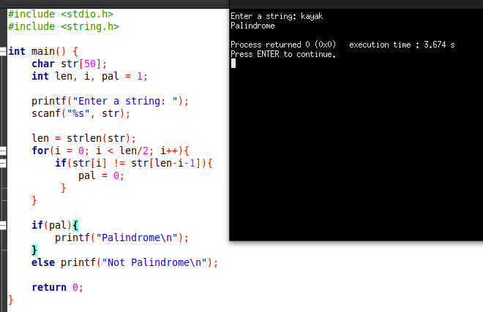

7. Pointers

Write a program to declare a pointer and print its address.
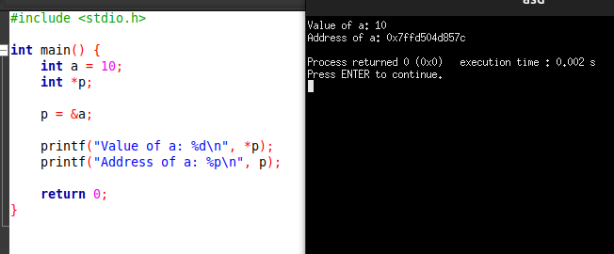
Write a program to swap two numbers using pointers.
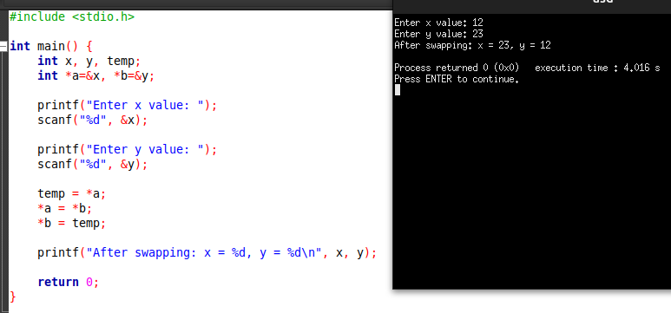
Create a program that dynamically allocates an integer using new.
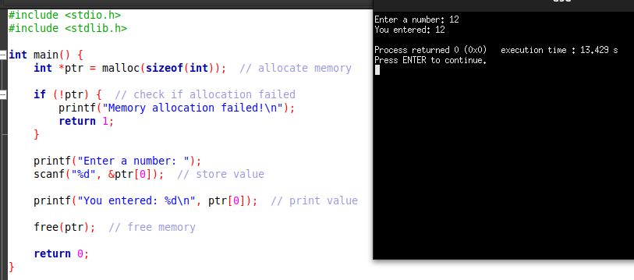

Write a program to find the sum of array elements using pointers.
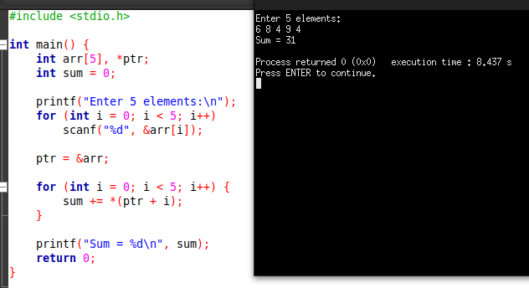
Write a program to reverse a string using pointers.
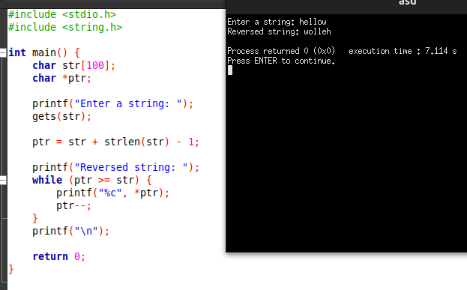
Write a program to find the length of a string using pointers.
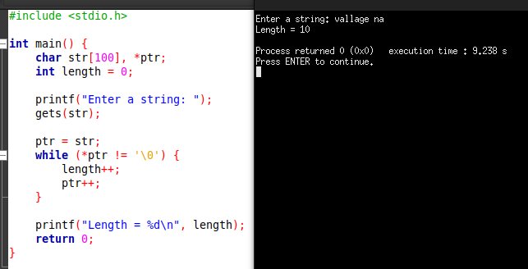

Write a program to demonstrate pointer arithmetic.
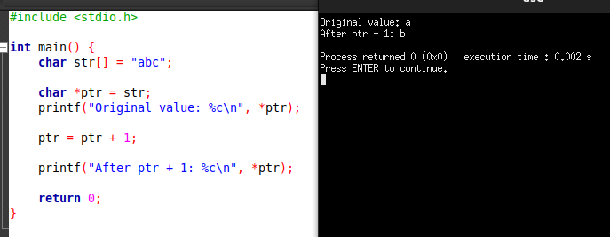
Write a program to create and delete a dynamic array using new and delete.
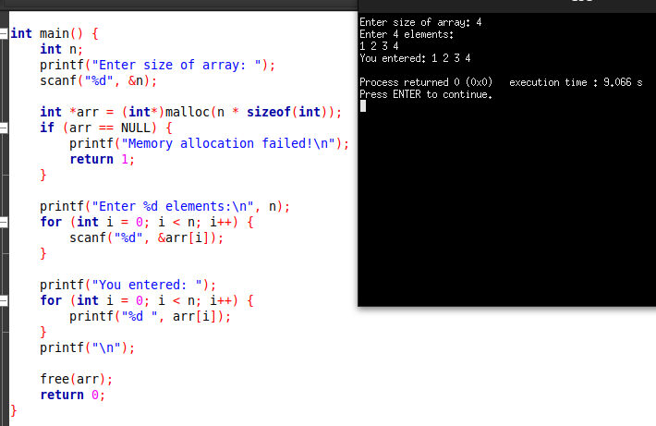
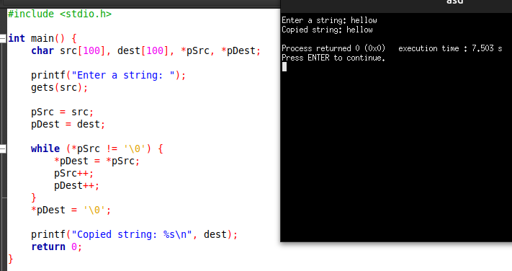
Write a program to copy a string using pointers.

Write a program to find the largest number in an array using pointers.
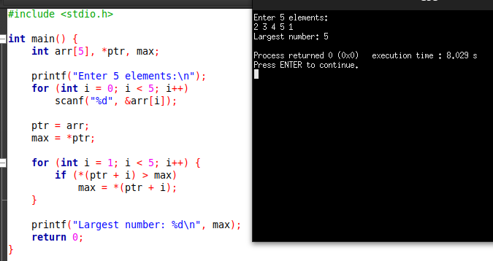

8. Structures and Unions

Write a program to define a structure for student details (name, roll, marks) and display them.
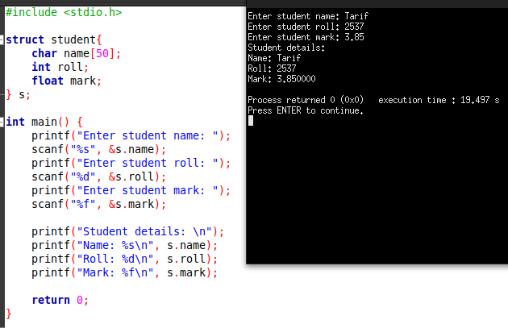

Create a structure to store the details of an employee and print them.
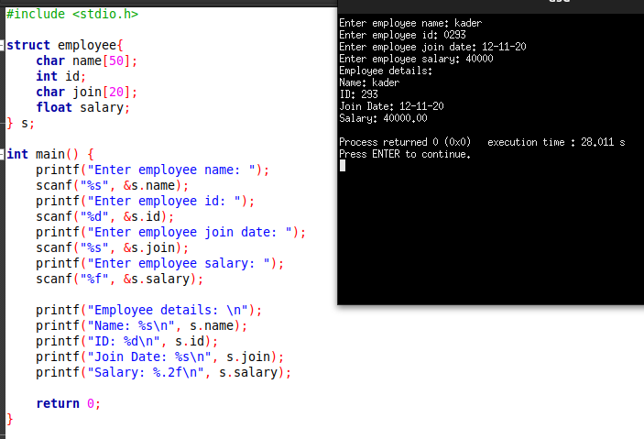

Write a program to store multiple students’ data using an array of structures.
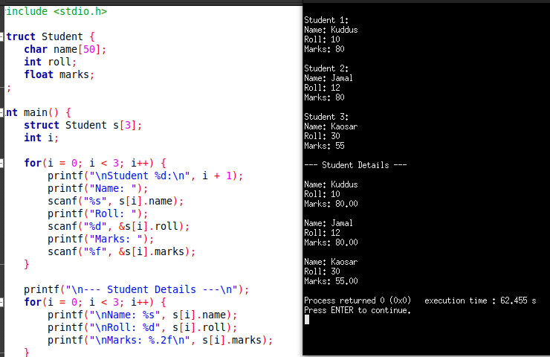

Create a structure for complex numbers and perform addition.
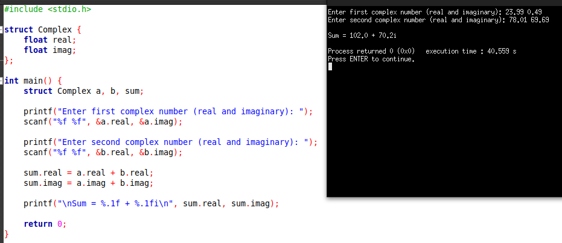
Write a program to find the largest of three numbers using a structure.
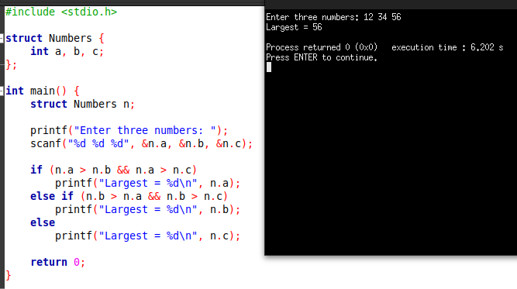
Write a program to swap two numbers using structures.
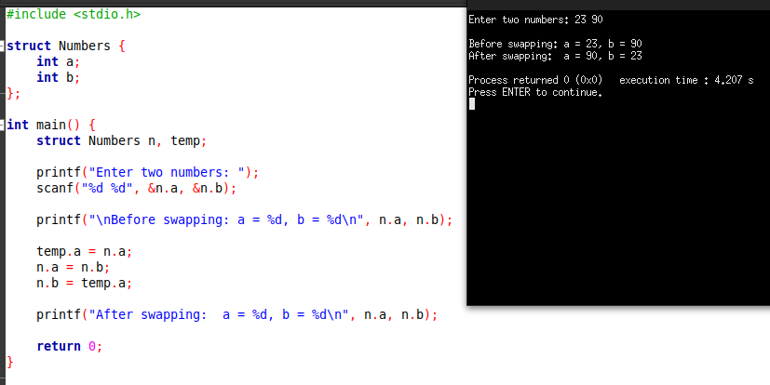

Define a union and demonstrate memory sharing between members.
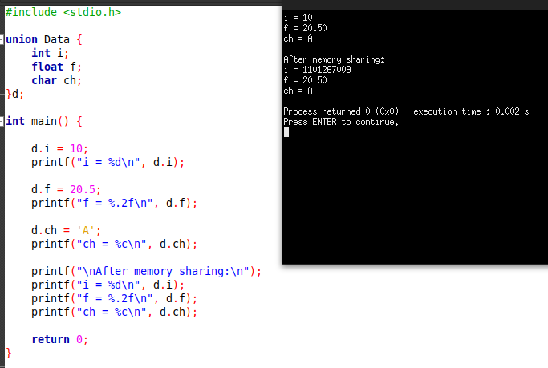

Create a program to store the details of multiple employees using structures.
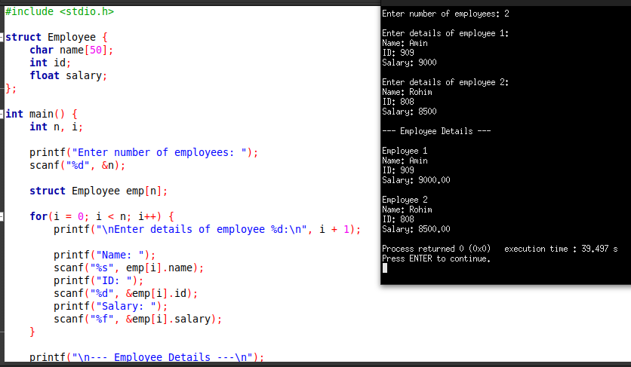

Write a program to take user input and display the details using structures.
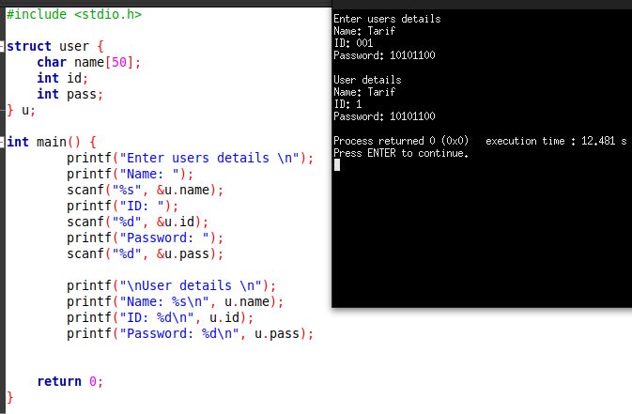

Write a program to compare two structures.
